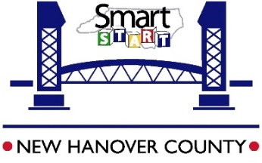
Smart Start Early Care and Education
2018.2019 Dedication to Education Bonus
Center Application

Please print clearly.

Full Name of Center:____________________________________________________________________
Center Address: _______________________________________________________________________
street city st zip
Center Phone: (__________)____________________Email: ____________________________________
Administrator’s Name:___________________________________________________________________
Current Star Rating:____________________________ Ages of Children Served:___________________
What are your Education Points on your current star-rated license*? ___________
*This will be verified by Smart Start staff

Eligibility Requirements
- The Dedication to Education Bonus is intended for Star-Rated Child Care Centers in New Hanover County who have achieved 5-7 Education Points on their Star-Rated License.
- Centers must be serving children under the age of five, and employ more than 2 staff.
- Centers will be eligible to receive a bonus (up to $1500). The amount of each bonus will be dependent upon total number of eligible applications received and funds available.
- Each applicant will be notified of acceptance status by May 10th. Documentation, including a signed contract and a W-9 tax form, must be submitted before a bonus is issued. The documentation will be provided by Smart Start.
- Applications must be submitted to Smart Start of NHC by Friday, April 19th at 5pm.
Dedication to Education Bonus checks will be mailed on or before June 30th, 2019.

I have read the fact sheet and application carefully. To the best of my knowledge, everything on the application is complete and correct. I understand that the funding for the Dedication to Education Bonus is dependent and contingent upon approval from the North Carolina Partnership for Children and availability of funds from the state of North Carolina, as approved by the N.C. General Assembly. I also understand that in order to be eligible for this bonus, the center must be in good standing DCDEE and Smart Start of New Hanover County (ex. no outstanding fees or resources).

Signature: ________________________________________________ Date: _____________________
Applications are due by: Friday, April 19th at 5:00pm.
Please return application via mail or hand delivery to: Smart Start of NHC- attn: Mindy Davis, 3534 S. College Rd., Suite F, Wilmington,
NC 28412
Faxed/Emailed applications will not be accepted.

